**Joseph Tierney**

**Computer Science 2**

**Database Assignment Report**

**“Another Century” DVD Rental Store Management System**

**Mission Statement**

This report describes the project development of a DVD Database Management System that was developed to manage the daily operation of a DVD rental store more efficiently. The purpose of the DVD database system is to maintain the data that is used and generated to support the DVD rental business.

**Project Aims and Objectives**

The project objectives are:

* To record every DVD in the database, this would include title, director, genre, age-rating, run time, release date and price
* To record DVD rentals and overdue rentals
* To record DVD rental fines
* To enable fast access to contact details of members and staff and suppliers and to add and remove details
* To order DVD’s
* To maximize efficiency
* To reduce paper work
* To be able to add new members electronically instead of manually with paper
* To keep track of suppliers details
* To produce a technical report that documents all details of the project

**Background of Project**

A DVD Rental Store Management System is an application which is suitable to use by a small and medium size store. It is used by staff members to manage the store using a computerized system. The system was developed and designed to help the staff record every DVD transaction. The system includes DVDs, Members, Suppliers and Staff sections. Staff can register or edit the members or DVDs in the system.

**My Role**

I have been hired by “Another Century” DVD Rental Store, based in Henry Street, City Centre, to create a database that will enable them to manage their business operations more effectively. The staff is responsible for managing and keeping track of all DVDs, members and DVD rentals. The system used up to now has been a non-electronic, manual system which stored the stores member’s details and the details of the DVDs separately.

**Requirements Gathering**

* To be able to search DVD’s in relation to Genre, release date, title, director, age rating, and price
* Need to register members
* To be able to search and see members contact details
* To be able to update members details
* To be able to see what DVDs have been rented and to what members
* To be able to view members who have overdue DVDs
* To register DVD details
* To be able to search and see contact details of staff members
* To be able to register new members
* To be able to search and see supplier contact details
* To be able to add new staff members and remove staff details
* To be able to update staff member and supplier contact details
* To be able to update DVDs costs

**Process Flow**

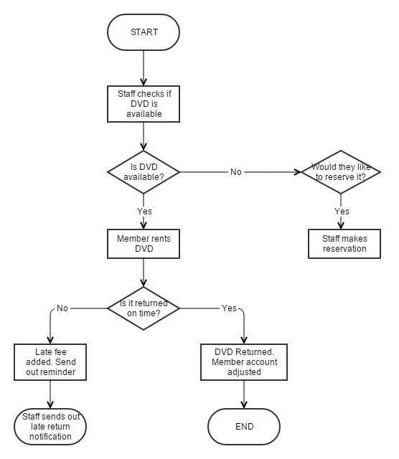

**Functional Components and Assumptions**

* Register Member: New Member can register
* DVD Issue: Here the DVD’s will be issued to the user
* DVD Return: Here the DVD’s are returned
* Search and view DVD details: It is used to search and view the DVDs
* Search and view Member details: It is used to search and view members
* Search and view Staff details: It is used to search and view staff
* Search and view Supplier details: It is used to search and view suppliers

**Business Rules**

* A DVD can only have one copy
* A DVD can be rented by one person at a time
* A member can rent up to 3 DVDs at a time
* Each DVD has an issue date and a due back date
* A person may not rent a DVD if one of their current ones are overdue
* Only members can rent DVDs

**Conceptual Design**

Step 1 – Identify main entity types

Step 2 – Identify main relationship types

Step 3 – Draw rough ERD

Step 4 – Fill in cardinality

Step 5 – Determine primary keys

Step 6 – Draw key based ERD

Step 7 – Identify

Step 8 – Map attributes

Step 9 – Draw fully attributed ERD

Step 10 – Review with end user

**Step 1 – Identify main entity types**

DVD

Member

Staff

Supplier

**Step 2 – Find Relationships**

|  |  |  |  |  |
| --- | --- | --- | --- | --- |
|  | Members | DVDs | Staff | Supplier |
| Member |  | Rents | Is served by |  |
| DVD | Is rented by |  | are managed by | Are supplied by |
| Staff | Serves | Manages |  | Orders from |
| Supplier |  | Supplies | Gives quote |  |

**Step 3 – Draw Rough ERD**

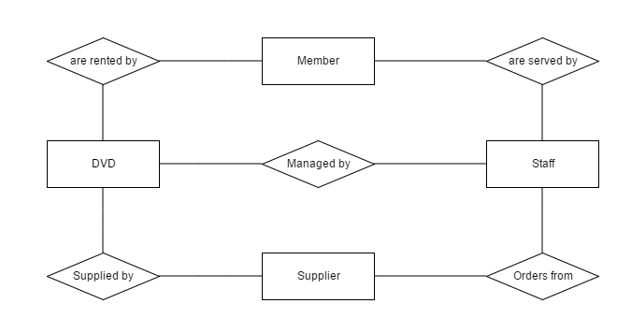

**Step 4 – Fill in Cardinality**

One Member can rent many DVDs, one DVD can be rented from many members (Many to Many)

One member can rent many DVDs, but a rented DVD can only be associated with one member (One to Many)

Many DVDs can be supplied by the one supplier, one supplier may provide many DVDs (Many to One)

One member of staff servers many members, however many members are served by one member of staff (Many to One)

One staff member can order from many suppliers, however many suppliers take orders from one member of staff (One to Many)

Many DVDs are managed by one member of staff, one staff member manages many DVDs (Many to One)

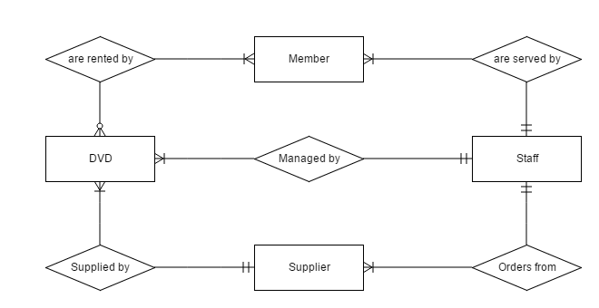

**Step 5 – Determine primary keys**

Entity Primary Keys

DVD DVDId

Members MemId

Staff StaffId

Suppliers SuppId

**Step 6 – Draw key based ERD**

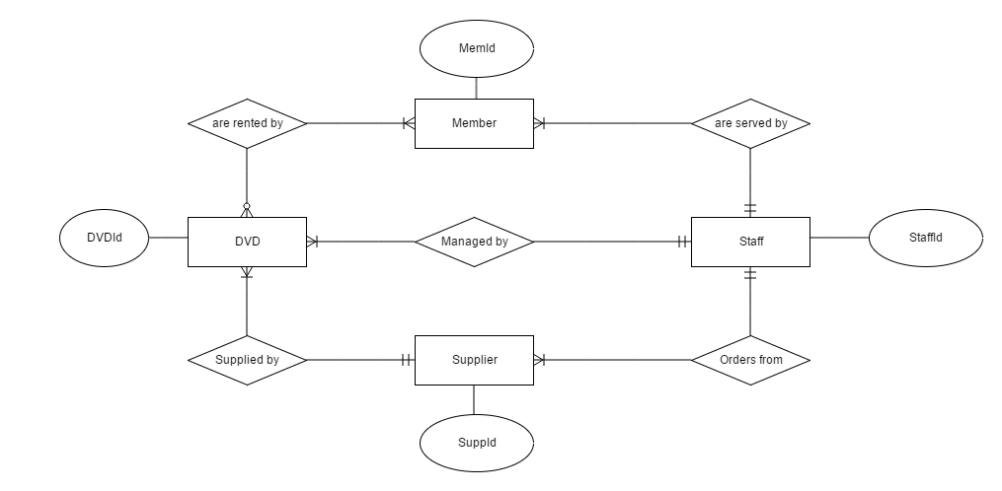

**Step 7 – Identify Attributes**

Members have MemId, MemName, MemAddress, MemPhone, MemEmail, and MemDOB

DVDs have DVDId, DVDTitle, DVDPublisher, DVDGenre, DVDCost, DVDRunTime, DVDAgeRating and DVDDirector

Staff have StaffId, StaffName, StaffAddress, StaffPhone, and StaffEmail

Suppliers have SuppId, SuppAddress, SuppName, SuppPhone, and SuppEmail

**Step 8 – Map Attributes**

|  |  |
| --- | --- |
| **Entity** | **Attributes** |
| Member | MemId, MemName, MemAddress, MemPhone, MemEmail, MemDOB |
| DVD | DVDId, DVDTitle, DVDPublisher, DVDGenre, DVDCost, DVDRunTme, DVDAgeRating, DVDDirector |
| Staff | StaffId, StaffName, StaffAddress, StaffPhone, StaffEmail |
| Suppliers | SuppId, SuppAddress, SuppName, SuppPhone, SuppEmail |

**Step 9 – Draw Fully Attributed ERD**

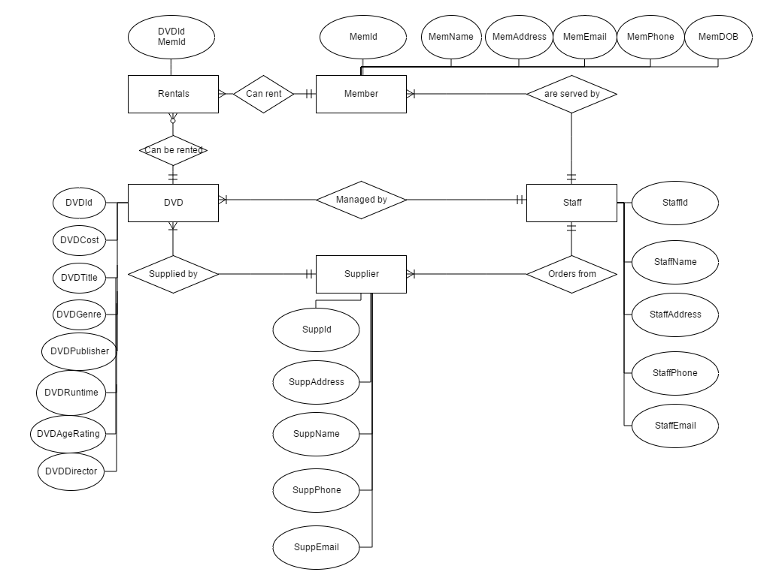

**Step 10 – Check Results**

Everything is clear. The cardinality pairs are in order and the list of attributes match up with the Entities.

**Normalisation**

|  |  |  |  |
| --- | --- | --- | --- |
| **UNF** | **1st NF** | **2nd NF** | **3rd NF**  **DVD Table** |
| **PK** Member ID | **PK** Member ID | **PK** DVD ID | **PK** DVD ID |
| Member Name | **PK** DVD ID | DVD Title | DVD Title |
| Member Address | DVD Title | DVD Publisher | DVD Publisher |
| Member Phone | DVD Publisher | DVD Genre | DVD Genre |
| Member Email | DVD Genre | DVD Cost | DVD Cost |
| Member DOB | DVD Cost | DVD Runtime | DVD Runtime |
| DVD ID | DVD Runtime | DVD Age rating | DVD Age rating |
| DVD Title | DVD Age rating | DVD Director First Name | DVD Director First Name |
| DVD Publisher | DVD Director First Name | DVD Director Surname | DVD Director Surname |
| DVD Genre | DVD Director Surname |  | **Rentals Table** |
| DVD Cost |  | **PK** Member ID | **PK** Member ID |
| DVD Runtime | **PK** Member ID | **PK** DVD ID | **PK** DVD ID |
| DVD Age rating | Member First Name |  | **Staff Table** |
| DVD Director | Member Surname | **PK** Member ID | **PK** Staff ID |
| Staff ID | Member Address 1 | Member First Name | Staff First Name |
| Staff Name | Member Address 2 | Member Surname | Staff Surname |
| Staff Address | Member Address 3 | Member Address 1 | Staff Address 1 |
| Staff Phone | Member Phone | Member Address 2 | Staff Address 2 |
| Staff Email | Member Email | Member Address 3 | Staff Address 3 |
| Supplier ID | Member DOB | Member Phone | Staff Phone |
| Supplier Address | Staff ID | Member Email | Staff Email |
| Supplier Name | Staff First Name | Member DOB | **Supplier Table** |
| Supplier Phone | Staff Surname | Staff ID | **PK** Supplier ID |
| Supplier Email | Staff Address 1 | Staff First Name | Supplier Address 1 |
|  | Staff Address 2 | Staff Surname | Supplier Address 2 |
| Staff Address 3 | Staff Address 1 | Supplier Address 3 |
| Staff Phone | Staff Address 2 | Supplier First Name |
| Staff Email | Staff Address 3 | Supplier Surname |
| Supplier ID | Staff Phone | Supplier Phone |
| Supplier Address 1 | Staff Email | Supplier Email |
| Supplier Address 2 | Supplier ID | **Member Table** |
| Supplier Address 3 | Supplier Address 1 | **PK** Member ID |
| Supplier First Name | Supplier Address 2 | Member First Name |
| Supplier Surname | Supplier Address 3 | Member Surname |
| Supplier Phone | Supplier First Name | Member Address 1 |
| Supplier Email | Supplier Surname | Member Address 2 |
|  | Supplier Phone | Member Address 3 |
| Supplier Email | Member Phone |
|  | Member Email |
| Member DOB |
| **\*FK** Supplier ID |
|  | | | **\*FK** Staff ID |

**Data Dictionary**

|  |  |  |  |
| --- | --- | --- | --- |
| **Database Structure Form** | | | |
| **Field Name** | **Data Type** | **Field Size** | **Notes** |
| **DVD Table** | | | |
| DVD ID (Primary Key) | Short Text | 255 |  |
| DVD Title | Short Text | 255 |  |
| DVD Publisher | Short Text | 255 |  |
| DVD Director First Name | Short Text | 255 |  |
| DVD Director Surname | Short Text | 255 |  |
| DVD Genre | Short Text | 255 |  |
| DVD Cost | Currency | € |  |
| DVD Run Time | Short Text | 255 |  |
| DVD Age Rating | Short Text | 255 |  |
| **Member Table** | | | |
| Member ID (Primary Key) | Short Text | 255 |  |
| Member First Name | Short Text | 255 |  |
| Member Surname | Short Text | 255 |  |
| Member Address 1 | Short Text | 255 |  |
| Member Address 2 | Short Text | 255 |  |
| Member Address 3 | Short Text | 255 |  |
| Member Phone | Number | Long Integer |  |
| Member Email | Short Text | 255 |  |
| Member DOB | Date/Time | Short Date |  |
| **Rental Table** | | | |
| Rental ID (Primary Key) | AutoNumber | Long Integer |  |
| Member ID | Short Text | 255 |  |
| DVD ID | Short Text | 255 |  |
| Check Out Date | Date/Time | Short Date |  |
| Return Date | Date/Time | Short Date |  |
| **Staff Table** | | | |
| Staff ID (Primary Key) | Short Text | 255 |  |
| Staff First Name | Short Text | 255 |  |
| Staff Surname | Short Text | 255 |  |
| Staff Address 1 | Short Text | 255 |  |
| Staff Address 2 | Short Text | 255 |  |
| Staff Address 3 | Short Text | 255 |  |
| Staff Phone | Number | Long Integer |  |
| Staff Email | Short Text | 255 |  |
| **Supplier Table** | | | |
| Supplier ID (Primary Key) | Short Text | 255 |  |
| Supplier First Name | Short Text | 255 |  |
| Supplier Surname | Short Text | 255 |  |
| Supplier Address 1 | Short Text | 255 |  |
| Supplier Address 2 | Short Text | 255 |  |
| Supplier Address 3 | Short Text | 255 |  |
| Supplier Phone | Number | Long Integer |  |
| Supplier Email | Short Text | 255 |  |

**Form Designs**

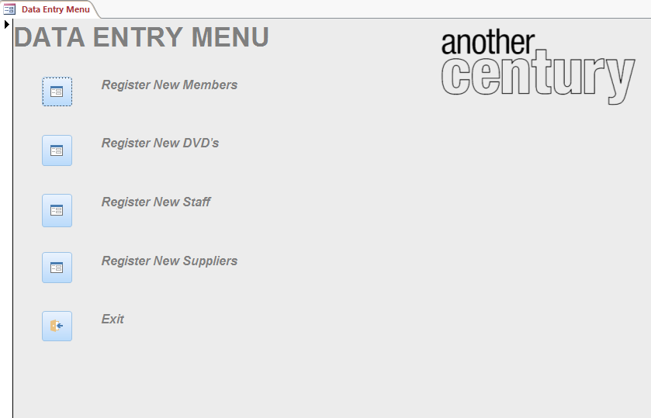

The Data Entry menu was designed using Command Buttons and Labels. The buttons on the form will open up other forms with relation to what they are called. Register New Members opens the Register New Members form, Register New DVDs opens the Register New DVDs form, Register New Staff opens the Register New Staff form etc. Exit closes the data entry menu.

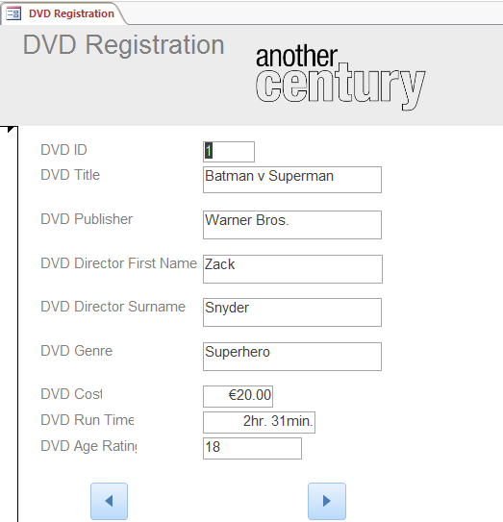

The DVD Registration form was designed by using the DVD Table and all of its fields. The navigation buttons bring the user to the next entry or previous entry. When clicking next on the last entry, the user will be able to add a new DVD to the system, which will update automatically.

The Fields include:

DVD ID

DVD Title

DVD Publisher

DVD Director First Name

DVD Director Surname

DVD Genre

DVD Cost

DVD Run Time

DVD Age Rating

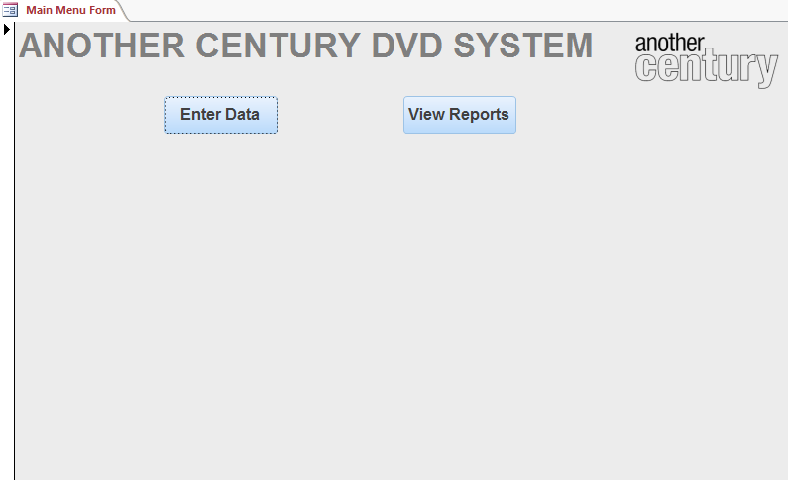

The main menu form is a simple design with just two command buttons. These buttons will open up either the Forms or the Reports. Clicking Enter Data will bring the user to the Data Entry Menu form and clicking View Reports will bring the user to the Reports Menu form.

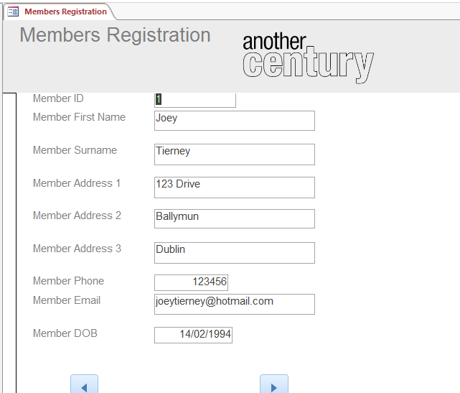

The Member Registration form was designed by using the Member Table and all of its fields. The navigation buttons bring the user to the next entry or previous entry. When clicking next on the last entry, the user will be able to add a new Member to the system, which will update automatically.

The Fields include:

Member ID

Member First Name

Member Surname

Member Address 1

Member Address 2

Member Address 3

Member Email

Member DOB

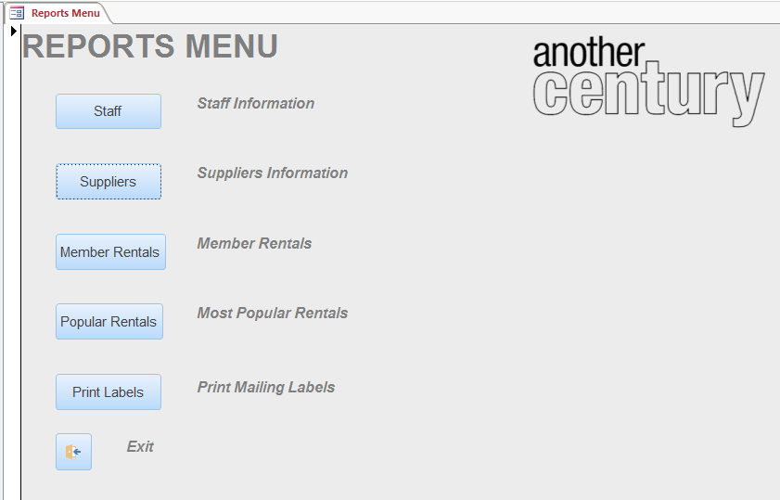

The Reports menu was designed using Command Buttons and Labels. The buttons on the form will open up reports in preview with relation to what they are called. Staff Information opens the Staff Information Report, Supplier Information opens the Supplier Information Report, Member Rentals opens the Member Rentals Report, Most Popular Rentals opens the Most Popular Rentals report and Print Mailing Labels will open the Labels for Members. Exit closes the reports menu.

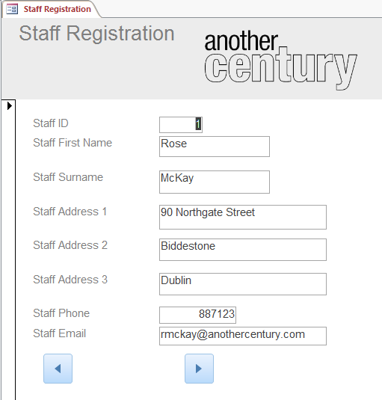

The Staff Registration form was designed by using the Staff Table and all of its fields. The navigation buttons bring the user to the next entry or previous entry. When clicking next on the last entry, the user will be able to add a new Staff member to the system, which will update automatically.

The Fields include:

Staff ID

Staff First Name

Staff Surname

Staff Address 1

Staff Address 2

Staff Address 3

Staff Phone

Staff Email

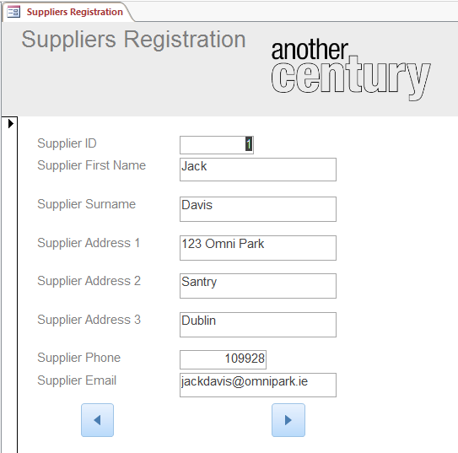

The Suppliers Registration form was designed by using the Suppliers Table and all of its fields. The navigation buttons bring the user to the next entry or previous entry. When clicking next on the last entry, the user will be able to add a new Supplier to the system, which will update automatically.

The Fields include:

Supplier ID

Supplier First Name

Supplier Surname

Supplier Address 1

Supplier Address 2

Supplier Address 3

Supplier Phone

Supplier Email

**Report Designs**

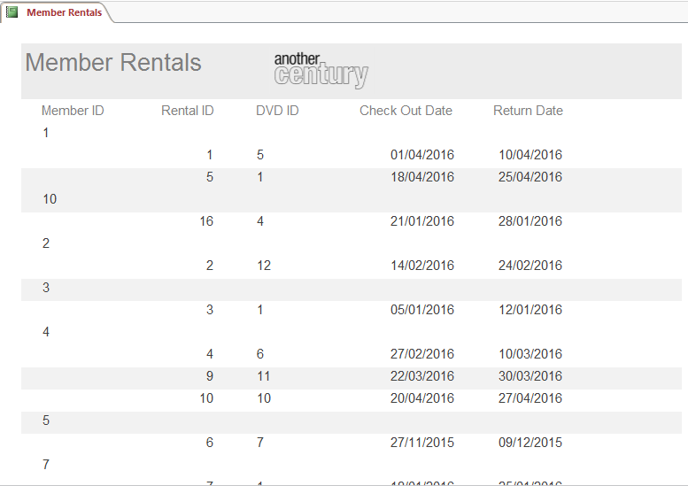

The member rentals report displays the Member ID, the Rental ID, DVD ID and the Check Out and Return Dates. The report is sorted in ascending order from the Member ID.

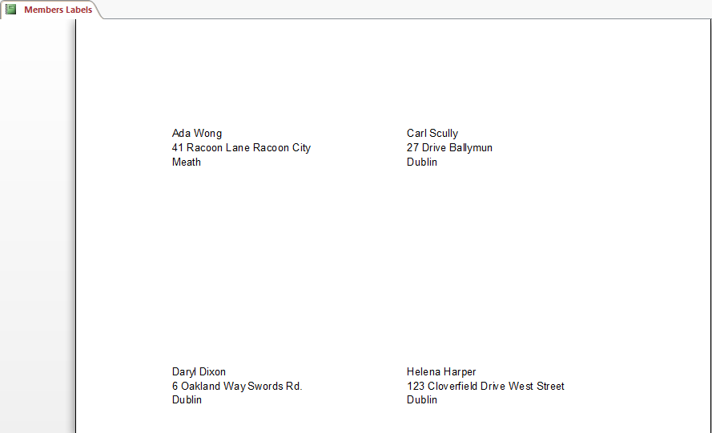

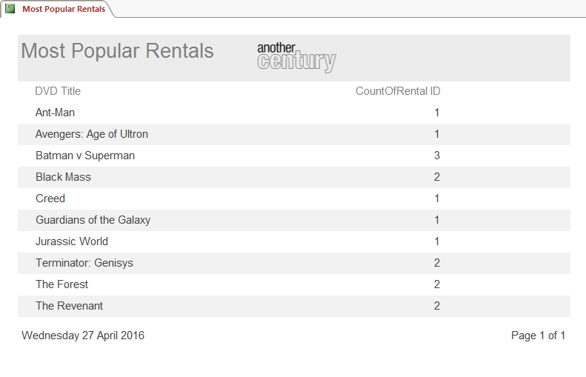

Most popular rentals report displays the DVD Title and the amount of times a DVD has been rented. The report is sorted in ascending order from the DVD title.

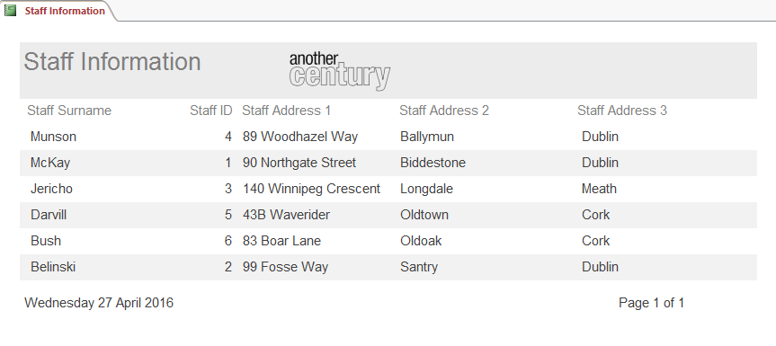The staff information report displays the Staff Surname, Staff ID, and Staff Address. The report is sorted in descending order from the staff’s surname.

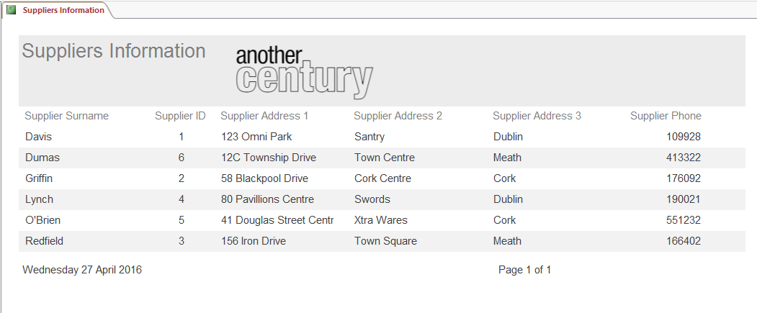

The supplier’s information report displays the Suppliers Surname, Supplier ID, Supplier Address and Supplier Phone. This report is sorted in ascending order from the Supplier’s surname.

**Queries**

All Staff Information will search the Staff table for all entries and display all details of the staff members.

SELECT *

FROM Staff;

The Heavy Renters query will display the Member ID and Member Names with a count of how many DVD’s they have rented.

SELECT Members.[Member ID], Members.[Member First Name], Members.[Member Surname], Count(Rentals.[Rental ID]) AS [CountOfRental ID]

FROM Members INNER JOIN Rentals ON Members.[Member ID] = Rentals.[Member ID]

GROUP BY Members.[Member ID], Members.[Member First Name], Members.[Member Surname]

ORDER BY Count(Rentals.[Rental ID]) DESC;

January Rentals query will display the Rental ID, DVD Title and Member Names with the date they checked it out (January).

SELECT Rentals.[Rental ID], DVD.[DVD Title], Members.[Member First Name], Members.[Member Surname], Rentals.[Check Out Date]

FROM DVD INNER JOIN (Members INNER JOIN Rentals ON Members.[Member ID] = Rentals.[Member ID]) ON DVD.[DVD ID] = Rentals.[DVD ID]

WHERE (((Rentals.[Check Out Date]) Between #1/1/2016# And #1/31/2016#));

Last Names with G query will display the Member ID, Member Name, Member Address and Member Phone Number

SELECT Members.[Member ID], Members.[Member First Name], Members.[Member Surname], Members.[Member Address 1], Members.[Member Address 2], Members.[Member Address 3], Members.[Member Phone]

FROM Members

WHERE (((Members.[Member Surname]) Like "G*"));

Most Popular Rentals query will display the Title of the most rented DVD’s and a count of the number of times it has been rented.

SELECT DVD.[DVD Title], Count(Rentals.[Rental ID]) AS [CountOfRental ID]

FROM DVD INNER JOIN Rentals ON DVD.[DVD ID] = Rentals.[DVD ID]

GROUP BY DVD.[DVD Title]

ORDER BY Count(Rentals.[Rental ID]) DESC;

**Conclusion**

Overall, I am satisfied with the outcome of my Database. It’s easy to use and navigate, and fulfils the needs that where required from Another Century. Adding new members will be easier than using the paper method, and keeping track of what has been rented and what are the most popular rentals is a great addition to help the company moving forward – as they know what stock to focus primarily on.

Challenges faced early on in the implementation phase of the Database was constructing the menu to view reports and open forms. During the creation the command buttons would not open the forms or the reports, this was eventually fixed because the “Form Operations” and “Report Operations” options had not been selected.